EXP 11 : MATLAB SIMULATION AND EVALUATION OF EYE DIAGRAM PARAMETERS UNDER INTER- SYMBOL INTERFERENCE IN DIGITAL COMMUNICATION SYSTEMS
SOFTWARE USED : MATLAB SOFTWARE

CODE :
clc; clear; close all

N=1000; sps=20;
bits=randi([0 1],1,N);
x=2*bits-1;
tx=repelem(x,sps);

% Introduce ISI using a channel filter
h=[1 0.5 0.25];
rx=filter(h,1,tx);
rx=awgn(rx,20,'measured');

figure;
subplot(3,1,1)
plot(tx(1:400)),title('Transmitted NRZ Signal'),grid on

subplot(3,1,2)
plot(rx(1:400)),title('Received Signal with ISI and AWGN'),grid on

subplot(3,1,3)
eyediagram(rx,2*sps)
title('Eye Diagram under ISI')

fprintf('Eye diagram shows signal distortion due to ISI.\n');
fprintf('Channel coefficients: 1, 0.5, 0.25\n');

MODEL GRAPH :
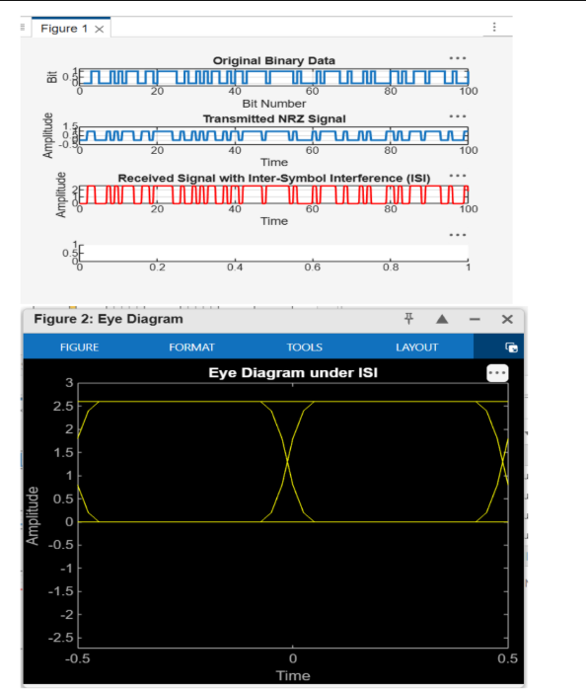

RESULT :
